3. Quantifying a component of fitness in the plants.

Fitness is the ability to survive and reproduce and as such it’s difficult to measure comprehensively. Generally, people measure traits that are correlated with survival and reproduction. For plants, size is a good predictor of the ability to survive and reproduce. There are many ways to measure size; for this project, you’ll measure total leaf area.

Using the sheet with a mm scale on it (at the end of this handout), write your group name, treatment and type of plant that you have on the paper in such a way that the leaves from each plant (which you will pull off of the plant) are in a group and set apart from the groups of leaves of each of the other plants (see below).
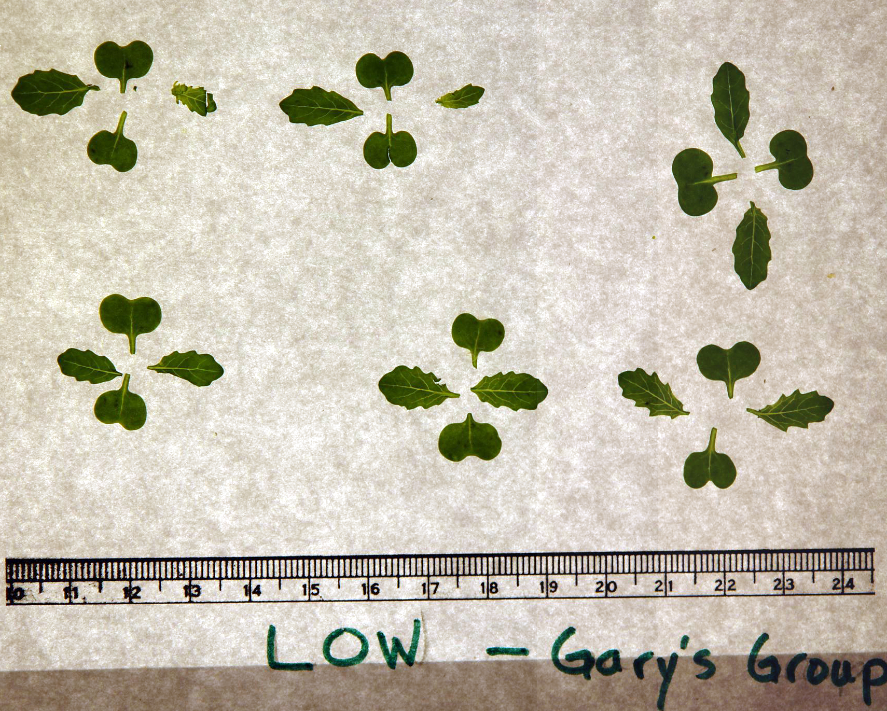

Carefully, take your paper with leaves to the camera setup and take a shot of the entire collection of leaves, labels and scale. If the picture from the camera is not a bmp (bitmap file), you will have to convert it to that format before proceeding.

Open Scion Image software and access the .bmp file with your picture of leaves on it.
The “red” slice (default) is perfect for this analysis. It might be necessary (if the picture is too large to fit on screen, under “edit” pull-down, select “scale and rotate”. For both horizontal and vertical scale boxes, enter .4 and then hit “OK”.

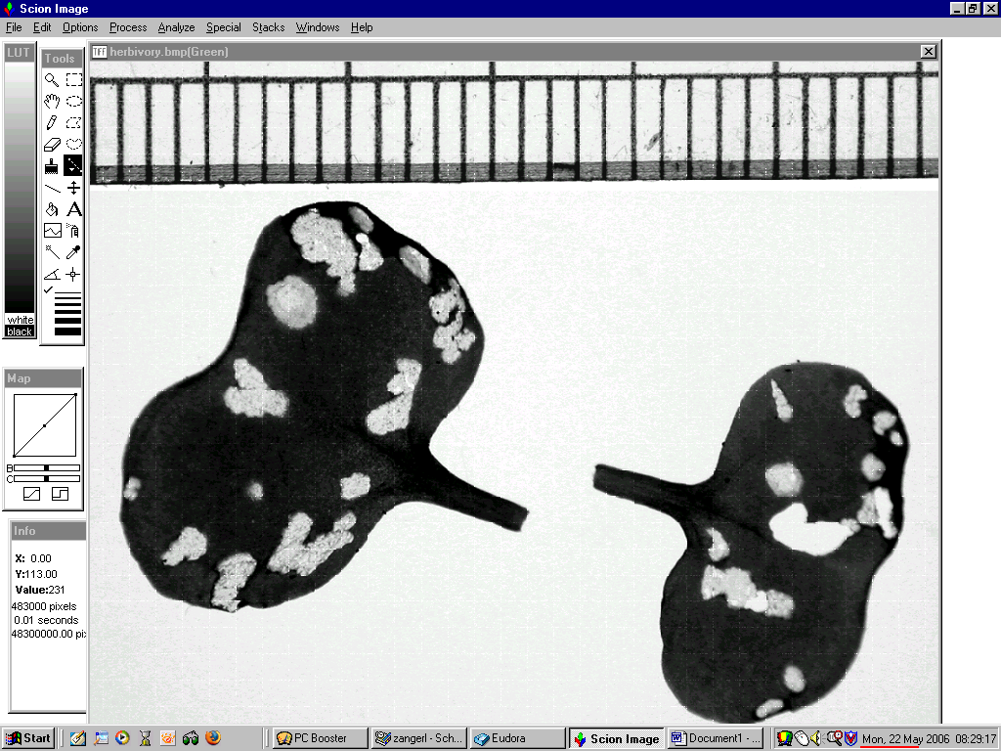

Using the scale tool (the item highlighted in black in the tool box), draw a straight line along the ruler that is 20mm (seen as a dotted line below):

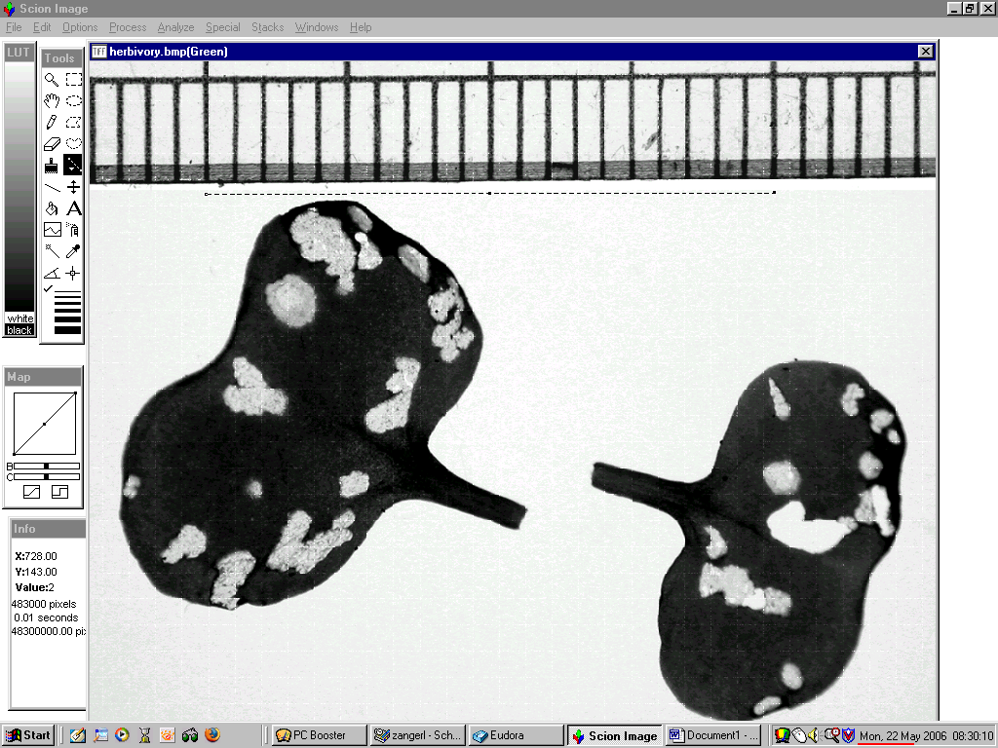

Choose “set scale” from the “Analyze” pull-down.

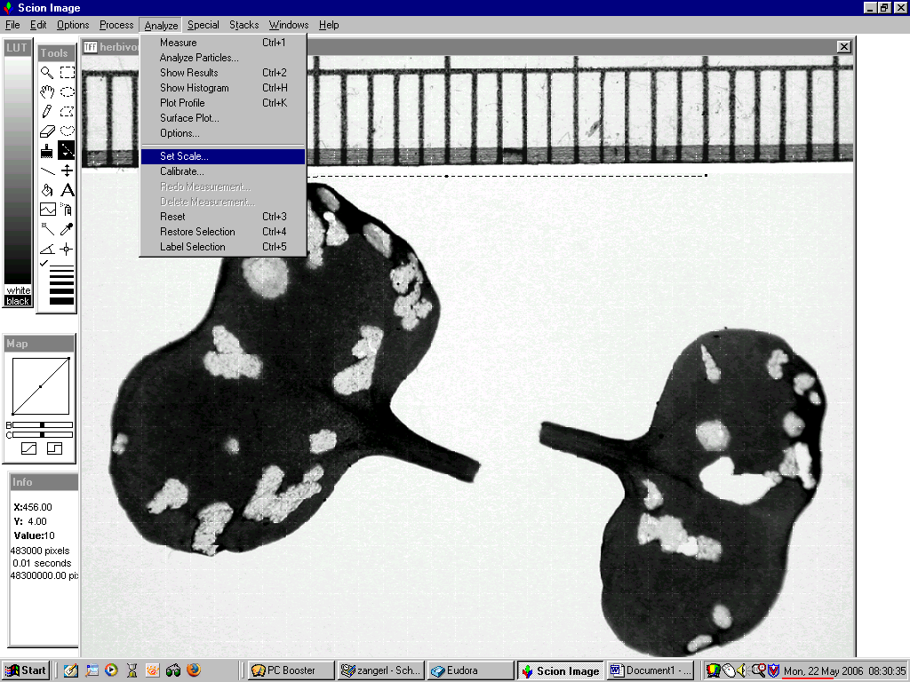

From the units box, select millimeters,
Then type in the number of millimeters long that your calibration line is (e.g., in this example we spanned 20 millimeters).

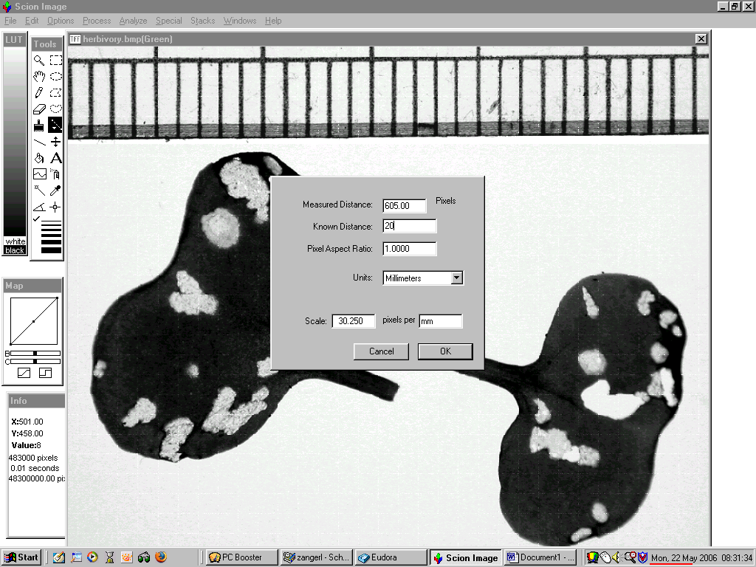

Select “density slice” from the “options” pull-down, and pull the lower end of the LUT bar to the bottom and the upper end of the red LUT bar toward the top until all of the leaf area is selected. Click your mouse to fix it there. Using the box tool, draw a box around one set of leaves and then take a measurement by selecting “measurement” from the “analyze” pull-down menu. Then, move to or redraw the box around another set of leaves and make another measurement. Continue until all sets of leaves have been measured.

Finally, you can see your results for all of the measurements by selecting “show results” from the “analyze” pull-down. The column headed by “area” is the area in square millimeters of leaf per plant.

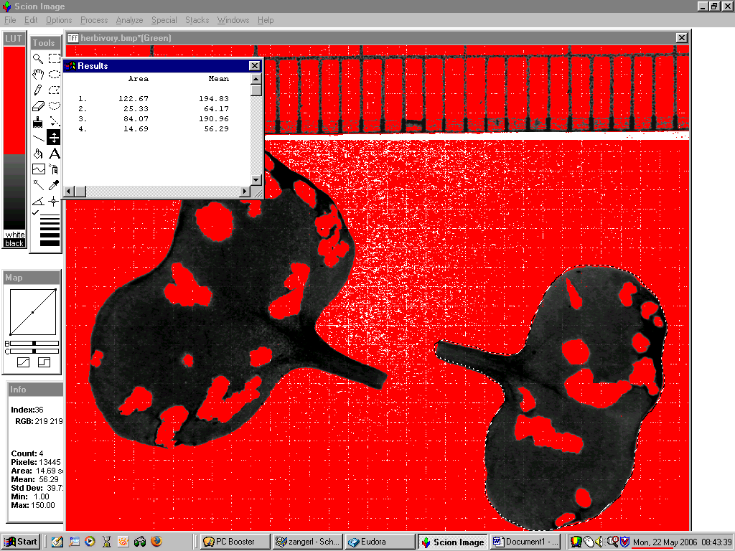

You can think of fitness of a seedling as being proportional to its size or leaf area.
Fitness = total leaf area minus leaf area of holes.

